Exploration completed：

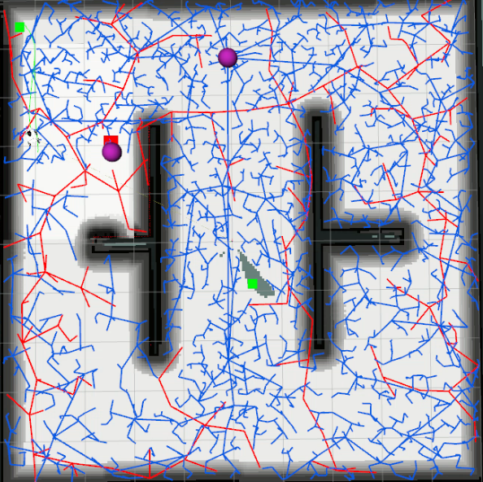

Defects：



Rate of coverage：98.8%